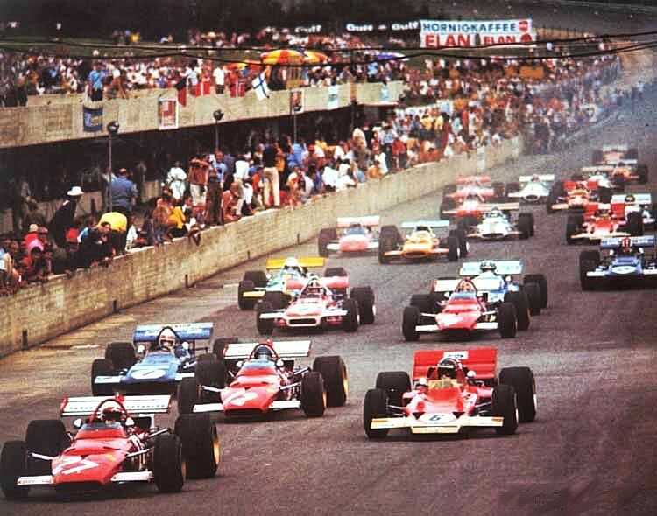

Wirral Super Prix
  - Policar F1 Classic 23 11th March 23

Wirral Slot Car Club is holding a Super Prix for the North West Clubs.

Cost is £15 total and that includes Hot Dogs ( vegetarian option available ) Contact paul.cooper.22@googlemail.com
Standard Policar F1 Classic with small modifications including F22 tyres and alloy wheels all Policar parts. Details specifics will be sent out to all entrants.
Space is limited to 20 persons so North West Clubs will initially have priority.
Address WSR , VALE PARK, WOODLAND DRIVE,WALLASEY CH45 1ND
Co

